PTou rapuotsoem /a Vticisailolyn classify school IT helpdesk tickets at creation using ServiceNow Flow Designer (no-code).

CUSTOMER SEGMENT(S)
Whoisyour customer?
i.e. working parents of 0-5 y.o. kids

CS 6. CUSTOMER CONSTRAINTS CC
Whatconstraints prevent yourcustomers from taking action or limit their choices
of solutions? i.e. spending power, budget, no cash, network connection, available devices.

AVAILABLE SOLUTIONS AS
Which solutions areavailable tothecustomers when they face the problem
Explore AS, differentiate
or need to get the job done? What have they tried in the past? What pros & cons do these solutions have? i.e. pen and paper is an alternative to digital notetaking

  - Students and teachers of the school who raise IT support tickets
(Wi-Fi, projector, password and slow-computer issues).
  - School IT helpdesk agents who receive, review and route these tickets.
  - Limited IT staff available to review every incoming request
  - manually.
  - Tickets must be classified correctly using standard Category and
  - Subcategory values (dependent choices).
  - The solution must be no-code and easy for the school to maintain. Users need confirmation that their request has been submitted. Process must handle growing request volume without extra effort.
  - Manual review: IT staff read each ticket and select the category and subcategory by hand.
Pros: human judgement. Cons: time-consuming, error-prone,
inconsistent and not scalable as requests increase.
  - Informing callers manually that a ticket has been created – adds extra effort for agents.
  - Our solution: Flow Designer automation classifies tickets on creation and sends an automatic email.

JOBS-TO-BE-DONE / PROBLEMS
Which jobs-to-be-done(or problems)do youaddress for your customers? There could be more than one; explore different sides.

J&P

9. PROBLEM ROOT CAUSE
What is the real reason that thisproblem exists?
What is the back story behind the need to do this job?
RC 7. BEHAVIOUR BE
Whatdoes yourcustomer do to address the problem and get the job done?
Focus on J&P, tap into BE, understand RC
i.e. directly related: find the right solar panel installer, calculate usage and benefits;

i.e. customers have to do it because of the change in regulations.
indirectly associated: customers spend free time on volunteering work (i.e. Greenpeace)

- Classify each incident automatically when it is created (Network / Hardware / Access / Performance).
- Reduce manual effort for IT agents.
- Improve ticket routing efficiency and consistency.
- Notify the caller that the request has been submitted.
- Provide a no-code, easily maintainable solution.
- The school IT helpdesk receives many incident requests daily from students and teachers on common issues: network connectivity, hardware failures, account access and system performance.
- Categories are assigned manually by IT staff, so the process is
slow, error-prone and does not scale as the number of requests grows.
- Students/teachers create an IT support ticket in the Incident Workflow table and enter a Short Description (e.g. “WiFi not working in library”).
- IT agents currently open each ticket, identify the issue type and manually select the Category and Subcategory.
- Agents then inform the caller that the ticket has been created.

TRIGGERS
What triggers customers to act? i.e. seeing their neighbour installing solar panels, reading about a more efficient solution in the news.
TR 10. YOUR SOLUTION SL
If you are working on an existing business, write down your current solution first, fill in the canvas, and check how much it fits reality.

CHANNELS of BEHAVIOUR CH

ONLINE
Extract online & offline CH of BE
What kind of actions do customers take online? Extract online channels from #7

    - A student or teacher creates a new ticket (Record Created) with the Category field left empty – this triggers the flow.
•
Frequent Wi-Fi, projector, password and slow-computer issues reported by students and teachers.
If you are working on a new business proposition, then keep it blank until you fill in the canvas and come up with a solution that fits within customer limitations, solves a problem and matches customer behaviour.
Flow: “Auto Classify School IT Tickets” (ServiceNow Flow Designer)
    - Ticket created online in ServiceNow (Incident Workflow form).
    - Flow runs automatically; confirmation email sent to caller.

EMOTIONS: BEFORE / AFTER
Howdo customers feelwhen theyface a problem or a job and afterwards?
•
•

EM •
Trigger: Record Created on Incident Workflow; condition: Category is Empty. If / Else If conditions check keywords in the Short Description:
WiFi/Network → Network / Wi-Fi; Projector → Hardware / Projector; Password/Login → Access / Forgot Password; Slow/Hanging → Performance /

OFFLINE
What kind of actions do customers take offline? Extract offline channels from #7 and use them for customer development.

i.e. lost, insecure > confident, in control - use it in your communication strategy & design.
Slow Computer. •

Before: unsure whether the request was received; agents spend time on manual review.
•
After: reassured by the confirmation email; tickets are classified correctly and agents
•
can focus on resolving.
    - Update Record sets Category and Subcategory; an automated email is sent to
    - the caller.
Maintained via Update Set (In progress → Complete, exportable as XML).
Offline (current process): IT agents manually review each request
    - and assign the category and subcategory.
Agents inform callers about ticket creation manually.

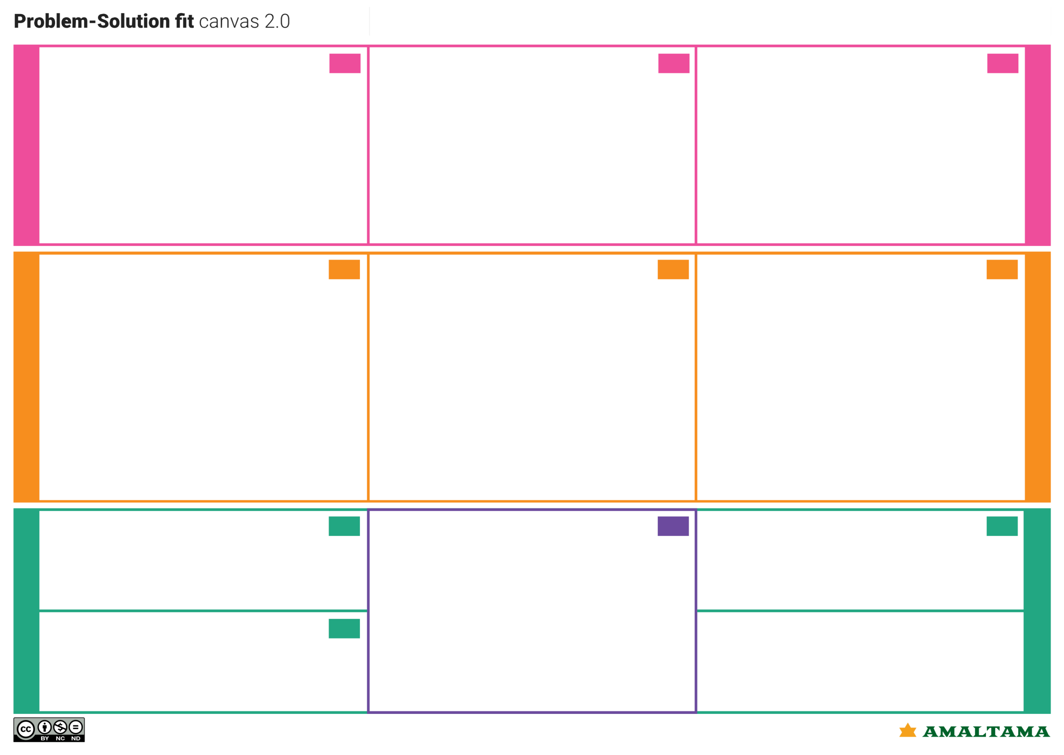
Identify strong TR & EM
Define CS, fit into CC
Focus on J&P, tap into BE, understand RC

Problem-Solution it canvas is licensed under a Creative Commons Attribution-NonCommercial-NoDerivatives 4.0 license Created by Daria Nepriakhina / Amaltama.com

Project Design Phase Problem – Solution Fit Template

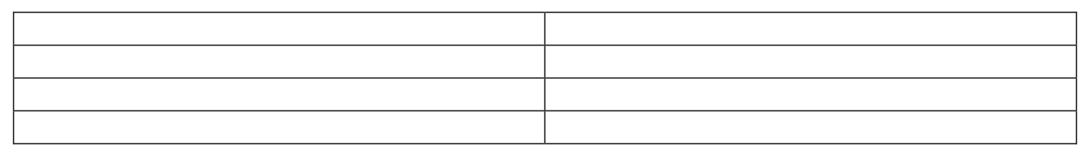
Date Team ID
Project Name
30 September 2026

SWTID-2026-7613
Auto Ticket Classification using Flow Designer

Maximum Marks 2Marks

Problem – Solution Fit Template:
The Problem-Solution Fit simply means that you have found a problem with your customer and that the solution you have realized for it actually solves the customer’s problem. It helps entrepreneurs, marketers and corporate innovators identify behavioral patterns and recognize what would work and why

Purpose:
      - Solve complex problems in a way that fits the state of your customers.
      - Succeed faster and increase your solution adoption by tapping into existing mediums and
channels of behavior.
      - Sharpen your communication and marketing strategy with the right triggers and messaging.
      - Increase touch-points with your company by finding the right problem-behavior fit and
building trust by solving frequent annoyances, or urgent or costly problems.

Understand the existing situation in order to improve it for your target group.

Template:

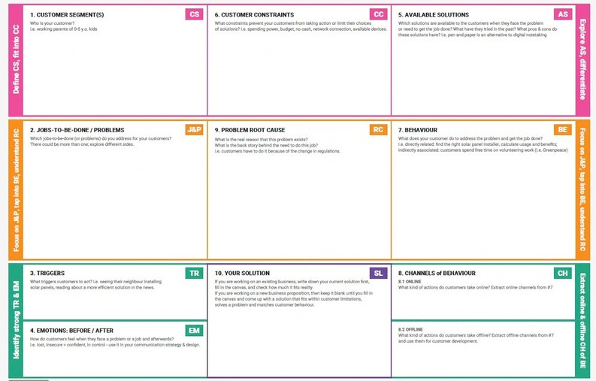
- Students and teachers who raise IT support tickets (Wi-Fi, projector, password, slow computer).
- School IT helpdesk agents who review and route tickets.

- Limited IT staff to review every request manually.
- Standard, dependent Category/Subcategory values are required.
- Solution must be no-code and easy to maintain.
- Callers need confirmation that the request was submitted.

- Manual review: agents read each ticket and pick the category by hand (time-consuming, error-prone, not scalable).
- Manual caller notification adds extra effort.
- Ours: Flow Designer auto-classifies and emails the caller.

  - Classify each incident automatically on creation (Network / Hardware / Access / Performance).
  - Reduce manual effort for IT agents.
  - Improve ticket routing efficiency.
  - Notify the caller of submission.
  - Keep the solution no-code and maintainable.

- The IT helpdesk receives many daily requests from students and teachers on network, hardware, access and performance issues.
- Categories are assigned manually by IT staff, which is slow, error-prone and does not scale as request volume grows.

- Student/teacher creates a ticket in the Incident Workflow table with a Short Description (e.g. “WiFi not working in library”).
- Agents currently identify the issue type and manually select Category and Subcategory.
- Agents then inform the caller.

  - New ticket created with Category empty (Record Created) triggers the flow.

  - Ticket created online in ServiceNow; flow runs and emails the caller.

  - Before: unsure if request was received; manual review workload.
  - After: reassured by confirmation email; tickets classified correctly.

Flow: “Auto Classify School IT Tickets”
- Trigger: Record Created on Incident Workflow; condition Category is Empty.
- If / Else If conditions check keywords in Short Description:
- WiFi → Network/Wi-Fi; Projector → Hardware/Projector; Password/Login →
Access/Forgot Password; Slow/Hanging → Performance/Slow Computer.
- Category and Subcategory updated; automated email sent to the caller.
- Maintained via Update Set (In progress → Complete, exportable as XML).

- Current process: agents manually review requests, assign the category and inform callers.

References:
- https://www.ideahackers.network/problem-solution-fit-canvas/
- https://medium.com/@epicantus/problem-solution-fit-canvas-aa3dd59cb4fe

